Date: | August 2020
Assessors Name(s): |  | Cyril Barratt / Heath McHugh |  | Team:
Coach:: |  |  |  | Signature: |  |  |  |  |  |  |  |  | Date:
Description of assessment |  |  | Coronavirus (COVID-19) Risk Assessment
Location Details |  |  | ECCLESFIELD or AWAY GAMES

Identified Hazards | Who may be affected | Risk Rating before control measures  High, Medium, Low |  |  | Control measures | Additional Control measures required | Residual Risk Rating  Following implementation of control measures
 |  | H | M | L |  |  | H | M | L
BEFORE TRAINING/ MATCHES  Transmission of Covid virus  Spreading /  Contracting | Players, Coaches, Parents/Carers | H |  |  | - Parents /Carers to advise coach if players have symptoms or are asymptomatic as soon as practicable. Those who are regarded as vulnerable / at risk should not attend without medical advice which should be conveyed to the coach prior to attending.  - Parents / Carers to ensure players bring / have access to hand sanitiser, if wearing gloves ensure these are for the individual user only DO NOT share gloves.  - Players must wear own clean kit and have own water bottle with their name on it.  - Players to ensure hand sanitiser is applied upon arrival at training / matches.  - Equipment to be cleaned with antibacterial cleaning products prior to training / matches commencing by coaches. Coaches advised to give themselves enough time prior to commencing. Keep equipment to a minimum.  - Coaches to inform attendees / spectators to maintain government / F.A. social distancing guidelines - 2m or 3 steps when providing information on training / match to parents / carers.  - Parents to inform players to minimise contact with others prior to attending training / matches. Parents / Carers to make themselves aware of government / F.A. / NHS / PHE Guidance & inform children prior to attending training / matches. | ALL PLAYERS MUST BE REGISTERED WITH BHR.  - Parents to sign training consent form / risk assessment acknowledgement prior to child commencing training / playing.  - Coaches to mark out spaces with cones if possible.  - If players bring own balls / equipment, ensure this is sanitised prior to attending or by coach prior to training / matches commencing. Coaches to inform parents if players are required to bring own equipment / balls.  - Coaches to keep a record of matches / opponents including contact details, inform opponents to do the same to support NHS Test and Trace. Ensure that coaches obtain away teams COVID risk assessment / information / rules when arranging away matches as rules / controls may vary at away venues.  - It is advised that players travel to / from venues with own family members or those within their support bubble as per government guidelines.  All players, coaches & spectators must undergo a self-assessment for any Covid-19- symptoms. No-one should leave home to participate in football if they, or someone they live with, has any of the following:  - A high temperature (above 37.8°C);  - A new, continuous cough;  - A loss of, or change to, their sense of smell or taste  - Other symptoms as set out by Public Health England  NOTE: Parents / Carers are responsible for carrying out an assessment of their child. | M

Identified Hazards | Who may be affected | Risk Rating before control measures  High, Medium, Low |  |  | Control measures | Additional Control measures required | Residual Risk Rating  Following implementation of control measures
 |  | H | M | L |  |  | H | M | L
ARRIVING AT TRAINING/ MATCHES  Transmission of Covid virus  Spreading /  Contracting | Players, Coaches, Parents/Carers | H |  |  | - Players MUST be accompanied by a parent / carer at matches  - Do not arrive too early for matches  - If possible arrive at matches together as a team and leave together  - Parents MUST ensure players are wearing right kit (coaches cannot help adjust kit during training/matches)  - Coaches to send players to parents / carers if not wearing right kit or if kit requires adjustment prior to commencing.  - Parents/carers to make sure that the coach has registered their youngster  - All coaches to keep a register of players in the group & those attending.  - Coaches to ensure footballs and all equipment is sanitised before commencing  - Do not use the changing facilities or toilets on Ecclesfield or those of the away team  - Remind parents & players of social distancing safety as set out above / by government / F.A. / NHS & PHE upon arrival at the venue.  - ENSURE THAT ALL PLAYERS & COACHES SANITISE HANDS AS SOON AS POSSIBLE UPON ARRIVAL & BEFORE COMMENCING TRAINING / MATCH. | Coaches to keep a record of BHR attendees / spectators at a match or training session, including contact details, inform opponents to do the same to support NHS Test and Trace.  Coaches, Parents & Players to maintain social distancing rules when arriving at the venue. DO NOT CLUSTER OR GATHER IN LARGE GROUPS when making their way to the pitches / on the touchline Once on the touchline maintain safe social distancing in accordance with government guidelines.  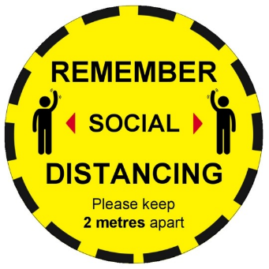 | M

Identified Hazards | Who may be affected | Risk Rating before control measures  High, Medium, Low |  |  | Control measures | Additional Control measures required | Residual Risk Rating  Following implementation of control measures
 |  | H | M | L |  |  | H | M | L
DURING TRAINING/ MATCHES  Transmission of Covid virus  Spreading /  Contracting | Players, Coaches, Parents/Carers | H |  |  | - Pre-match handshake should not happen. Check players have hand-sanitised prior to commencing / before kick-off.  - Team talk huddles should not take place. Team talks can take place, if social distancing is observed and held outdoors where possible.  - Warm-ups/cool-downs should always observe social distancing.  - Coaches, substitutes are allowed, but must also always observe social distancing on touchlines.  - Social distancing must also be observed during interactions when a substitution is being made.  - Avoid handling the ball unnecessarily – use feet to retrieve the ball e.g. when going out of play – inform spectators not to retrieve the ball.  - Set plays – free kicks: referees and coaches should encourage players to get on with the game and not unnecessarily prolong set play set-up, such as defensive walls.  - Set plays – corners should also be taken promptly to limit prolonged close marking.  - Players & coaches should avoid spitting.  - Players & coaches should avoid or raising their voices when facing each other during, before and after games.  - Equipment should be wiped down before matches, after matches and at half time.  - Goal celebrations should be avoided, discourage hugging & close contact. Ensure this is reinforced prior to kick-off.  - Interactions with referees / match assistants should only happen with players observing social distancing. | - Coaches must always follow FA/Clubs safeguarding policies  - Parents / Spectators MUST observe social distancing on the touchline in accordance with all guidelines & advice. Only have contact with their youngster and no other player.  - Parents to remain in view of their youngster at all times but well clear of the playing area.  - If parents want to talk to their youngster during training/matches, then the youngster must go to the parent and not visa versa  - Coaches should not administer first aid unless absolutely necessary.  - If any accidents occur, coach moves other players away to at least 2 meters and calls parent/carer across to injured youngster.  - If a serious injury occurs then other players return to parents and session / match is stopped.  - If a youngster becomes symptomatic during training/matches, stop the session and ensure all parents are aware of the issue using WhatsApp or other normal team communication  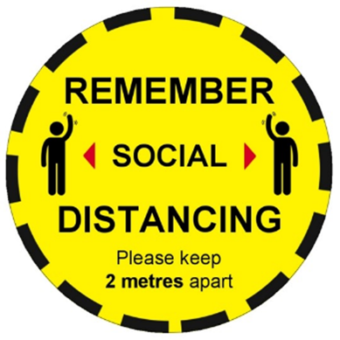  - Avoid bibs if possible, however if bibs are worn ensure that they washed between each session / match & keep handling to a minimum. | M

Identified Hazards | Who may be affected | Risk Rating before control measures  High, Medium, Low |  |  | Control measures | Additional Control measures required | Residual Risk Rating  Following implementation of control measures
 |  | H | M | L |  |  | H | M | L
AFTER TRAINING/ MATCHES  Transmission of Covid virus  Spreading /  Contracting | Players, Coaches, Parents/Carers | H |  |  | - Post-match handshake should not happen  - Maintain social distancing when dealing with match officials  - Payment to referee should be done in accordance with your league rules  - Players/coaches to sanitise hands as soon as possible  - Players/coaches/parents & spectators to remain at social distance when leaving the field / venue  - Handle equipment as little as possible  - Coaches to sanitise all equipment used  - Coaches to check record of youngsters attended  - Do not leave anything at all on the field  - Players to take home kit for parents / carers to wash  - If a player becomes symptomatic within a few days of training / match then parents to advise coach who will advise all other parents in the group & BHR secretary | Inform parents & players to maintain social distancing rules when leaving the touchline / venue. DO NOT CLUSTER OR GATHER INLARGE GROUPS TO GET AWAY A FEW MINUTES EARLIER.  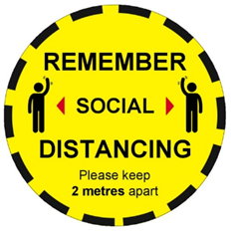 | M

CTRL & CLICK ON LINKS BELOW FOR GOVERNEMENT / NHS / F.A. INFORMATION / ADVICE

https://www.gov.uk/government/publications/staying-alert-and-safe-social-distancing

https://www.gov.uk/government/collections/coronavirus-covid-19-list-of-guidance

https://www.nhs.uk/conditions/coronavirus-covid-19/social-distancing/what-you-need-to-do/

http://www.thefa.com/news/2020/jul/17/grassroots-guidance-for-competitive-football-restart-in-england-170720

LOW | MEDIUM | HIGH
Continue with existing control measures, however monitor for changes.  Implement any additional control measures required. | Requires attention to reduce the rating as well as regular ongoing monitoring.  Implement any additional control measures required. | STOP - Requires immediate attention to bring the risk down to an acceptable level. Implement the control measures required and continue to review control measures & safe practices to reduce the risk.

IF UNSURE ON THE ABOVE CONTACT BLEAKHILL ROVERS WELFARE OFFICER / CHAIRMAN

welfare@bleakhillrovers.com info@bleakhillrovers.com

Additional comments:

- Parents to be given a copy of this risk assessment and are to sign an acknowledgement sheet for their understanding of the risk.
- The risk assessment is to be reviewed monthly, or sooner if a situation arises that requires a review
- This risk assessment must be sent to the Secretary before training sessions / matches are arranged / played.

Coaches name: |  | Signature: |  | Date:

Received by secretary |  | Signature: |  | Date:

I, the undersigned, have been fully briefed on this risk assessment and other control measures in place to reduce the risk of catching or spreading the covid virus
I fully understand as a parent/carer, to follow the control measures in this risk assessment and ensure my youngster follows the guidelines
Players name | Parent/carer signature | Date | Comments? | Coaches Signature

